ABORIGINAL WORLDVIEWS & PERSPECTIVES IN THE CLASSROOM
First Peoples principles of learning

From kindergarten to graduation, students will experience Aboriginal perspectives and understandings as an integrated part of their learning journey. The inclusion of Indigenous ways of knowing and being is based on the understanding that Aboriginal perspectives and knowledge are a part of the historical and contemporary foundation of BC and Canada.

An important goal in integrating Aboriginal perspectives into curricula is to ensure that all learners have opportunities to understand and respect their own cultural heritage as well as that of others. There are two important aspects to embedding these principles of learning into classroom experiences. First, all students will be celebrated as individuals in a strength-based, learner-centred environment and second, all students will be nurtured in their understanding of the healing around Truth and Reconciliation.

Coming in April – Place-Based Learning.

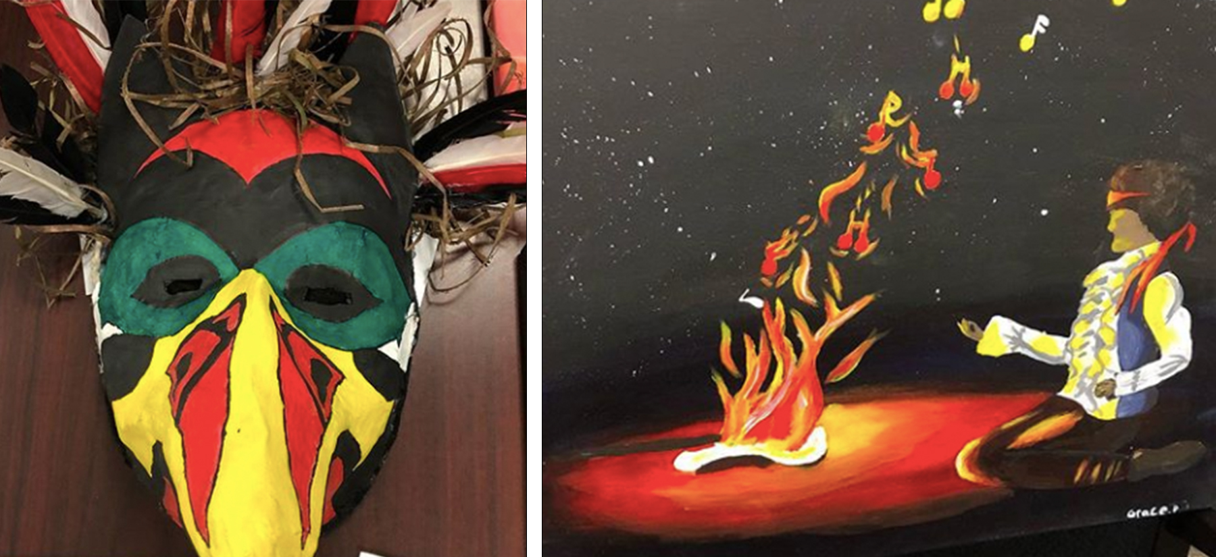

Senior art projects on display for judges from ACT (Feb. 2019)

