Maple Ridge Secondary
Pre-order Lunch Program

We are excited to announce that you can now place your student’s lunch order online using MunchaLunch.com! You can pay for your orders online using credit card (Visa/Mastercard), debit-credit card, Google Pay, Apple Pay or pre-paid credit card.

It’s super simple!

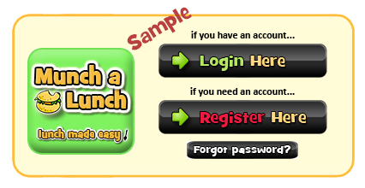
TO REGISTER:
- Go to: MunchaLunch.com
- Click the “Register Here” button (as shown below). The system will guide you through.
- After adding your student(s), click the green “Order Lunch!” button to order.
- Next time, just click the “Login Here” button to access your account.

ORDERING INFORMATION:
- Orders must be placed by 8:00 a.m. on the day of pickup.
- Students must collect their own lunch from the dedicated pickup area. If a lunch is not collected, it cannot be picked up later or the next day.
- There are no refunds with this pre-order process.
  - Uncollected lunches will be donated to a student who does not have a lunch.
  - It is the student’s responsibility to pick up their order—we are unable to page students.

VERY IMPORTANT!
Due to the fast pace of lunchtime service:
Your student must show their order confirmation (on their phone or a printed copy) or show photo ID at pickup so we can confirm the food

