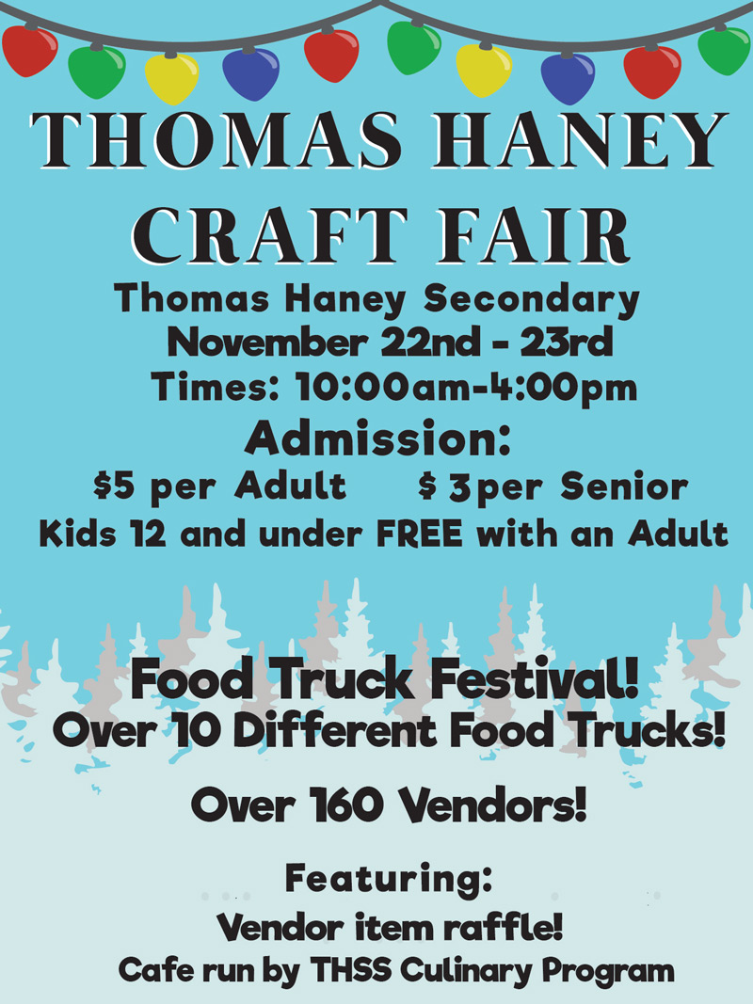
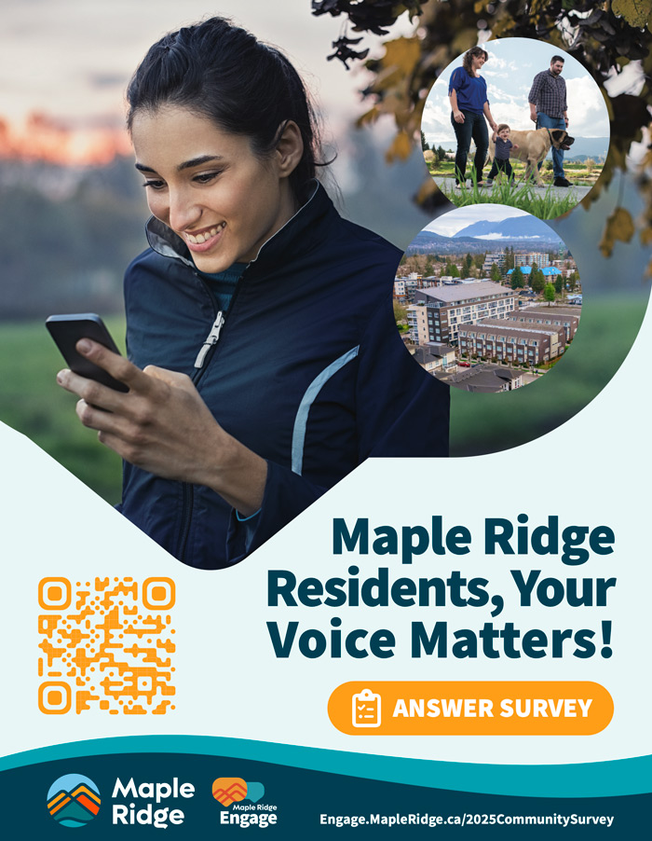



Parks, Recreation and Culture for Winter 2026

Winter Programs Are Here - Registration opens Tuesday, December 2 at 8 a.m.
Our winter program guide is now available online and will be available in print on November 18. The City of Pitt Meadows Parks, Recreation & Culture Guide is packed with a variety of activities, spring break camps, skating lessons, arts workshops and programs for all age groups! Registration for opens Tuesday, December 2 at 8 a.m. Visit pittmeadows.ca/programguide for details.

Low-Cost and Free Activities at Pitt Meadows Family Recreation Centre:
Parent & Tot Mini Gym 0-5Y
Looking for an indoor activity? PMFRC offers low-cost Parent & Tot Mini Gym in the gymnasium on Mondays and Wednesdays (10:05-11:45 a.m.) and Saturdays (9-11 a.m.) for only $1 per child.
Value Times at the Fitness Centre
Work out at the fitness centre during our value times. It’s only $1 for youth (13-18Y) and seniors (60Y+) and $2 for adults (19-59Y). Value times are: Tuesday 10-11:30 a.m., Wednesday 8-9 p.m., Thursday 6-7 a.m. and Saturday from 3-6 p.m.

Community Services - Let's Play (FREE Registered Program)
Let's Play is a vibrant and inclusive community program for all ages led by Community Services. Families will engage in a variety of play opportunities with their child, such as loose parts, sensory explorations, the wonder of art, music and movement, science discoveries and more. Registration is required. See location, dates and full details, or register at pittfitandfun.ca.

Upcoming Pitt Meadows FREE Family Events
The City of Pitt Meadows proudly hosts a number of community events throughout the year. Some upcoming events from January to March 2026 include the Family Day Carnival and Easter FunDay. For full details about community events and activities, visit pittmeadows.ca/specialevents.

FREE Family Lounge Drop-In Program – Sundays from 3-7 p.m.
Drop by the Constable Rick O’Brien Youth Lounge with your family! The Youth Lounge will open Sundays, from 3-7 p.m. for a time of unstructured activities for you and your children. Enjoy a variety of activities including billiards, ping pong, video games, retro arcade and board games. There is also a concession with food and drinks.

Our Recreation team will be on hand to supervise, but please remember that this is a parent-led program. Children must be accompanied by a parent or guardian at all times. Older siblings (11Y+) are also welcome, but must be accompanied by a parent/guardian.
For questions or details about this program contact the Youth Lounge Supervisor at abuckle@pittmeadows.ca or 604.465.2456.

Save on Your New Year's Fitness Goals!
Purchase a recreation membership at the Pitt Meadows Family Recreation Centre for 3 months or more, between January 2 to 31, 2026 and receive 10% off! *One pass per person, not applicable to 10, 20 visit, or one-month passes. Call 604.465.2452 or drop by the Pitt Meadows Family Recreation Centre for details.

Personal Training at the Pitt Meadows Family Recreation Centre
From Teen Weight Training to Personal Training, there are a variety of individual and group programs available. See full details in the Winter Guide.

Park Amenity and Grabenhorst Garden Donation Programs
The City of Pitt Meadows offers residents, community groups, businesses and visitors the opportunity to honour a loved one, commemorate a special occasion or give back to the community. From memorial plaques to benches, these programs are designed to create lasting tributes while supporting local spaces and initiatives. Learn more about the Grabenhorst Garden Donation Program and Parks Amenity Program in the Winter Guide.

Pitt Meadows Parks Projects
Looking for information about past, current or upcoming parks projects view the highlights in the winter guide or visit pittmeadows.ca/parksprojects for updates.

Experience Art & Culture at the Pitt Meadows Art Gallery
The Pitt Meadows Art Gallery (PMAG) is located on the main floor of the South Bonson Community Centre in Pitt Meadows. PMAG is committed to supporting local and regional artists and artisans and will showcase six exhibitions per year at the main gallery and four exhibitions per year at the pop-up gallery. Admission to the gallery is free and all work is available for sale.

The Pop-Up PMAG can be found in the lobby at City Hall. This satellite gallery showcases smaller collections of work from Lower Mainland artists.

For more information about the gallery and the exhibits visit pittmeadows.ca/pmag.

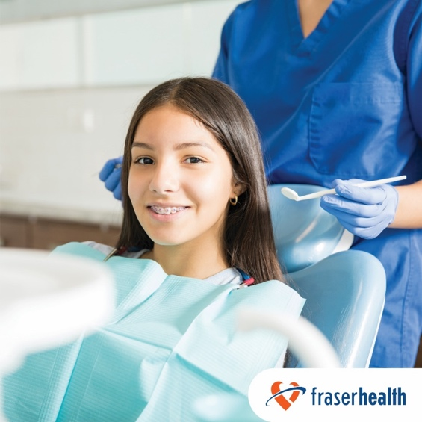

Vision, hearing and dental screenings and youth clinics

Make dental, hearing and vision checks part of a healthy routine
It’s important for your child to have regular eye exams and routine dental checkups. This can help find issues early and lead to better outcomes. It is also important to recognize any hearing loss early as this is essential for speech and language development.
Dental
Tooth decay and other oral health concerns are the most common preventable chronic diseases in children. Establishing good oral hygiene habits early and ensuring regular dental checkups are essential for your child’s oral health.
To find a local dentist who is accepting new patients, visit the BC Dental Association's Find a Dentist database.
If your family is experiencing financial challenges and doesn’t have extended health coverage, there are programs available to help make dental care more accessible. You can also reach out to the dental program at your local public health unit at Dental Care - Fraser Health to learn about community resources and support.
Vision
BC Doctors of Optometry (BCDO) recommends children receive their first eye exam when they are six to nine months old, with a follow up exam at least once between the ages of two and five, and then yearly once they enter school. You can find an optometrist accepting new patients near you on BCDO's website. In B.C., one basic eye exam per year is free up to the age of 18. Some optometrists may charge a user fee of about $35-50 per visit, so be sure to ask about any fees before you make an appointment. Find more information on BCDO’s Children’s Resources page.
Hearing
Good hearing is essential for speech and language development and plays an important part in a child's social and emotional growth. It is important to recognize hearing loss early and seek out testing and treatment if needed. Fraser Health’s Public Health community audiologists provide free hearing services for children from birth to 19 years of age. If you have a concern about your child's hearing, referrals can be made by a parent or caregiver, a health care provider or education professional to your local public health audiology (hearing) clinic.
Find more information on child health screenings and how to access free vision, hearing and dental exams on Fraser Health’s website.
Youth clinics
Let your teen know about our youth clinics. Located throughout the Fraser Health region, these clinics offer free and confidential sexual health care to youth, with age eligibility varying by site and service. Learn more about the services available at youth clinics here.

